SQL Operators

1. Use the SalesPerson table to calculate each person's commissions for SalesLastYear.

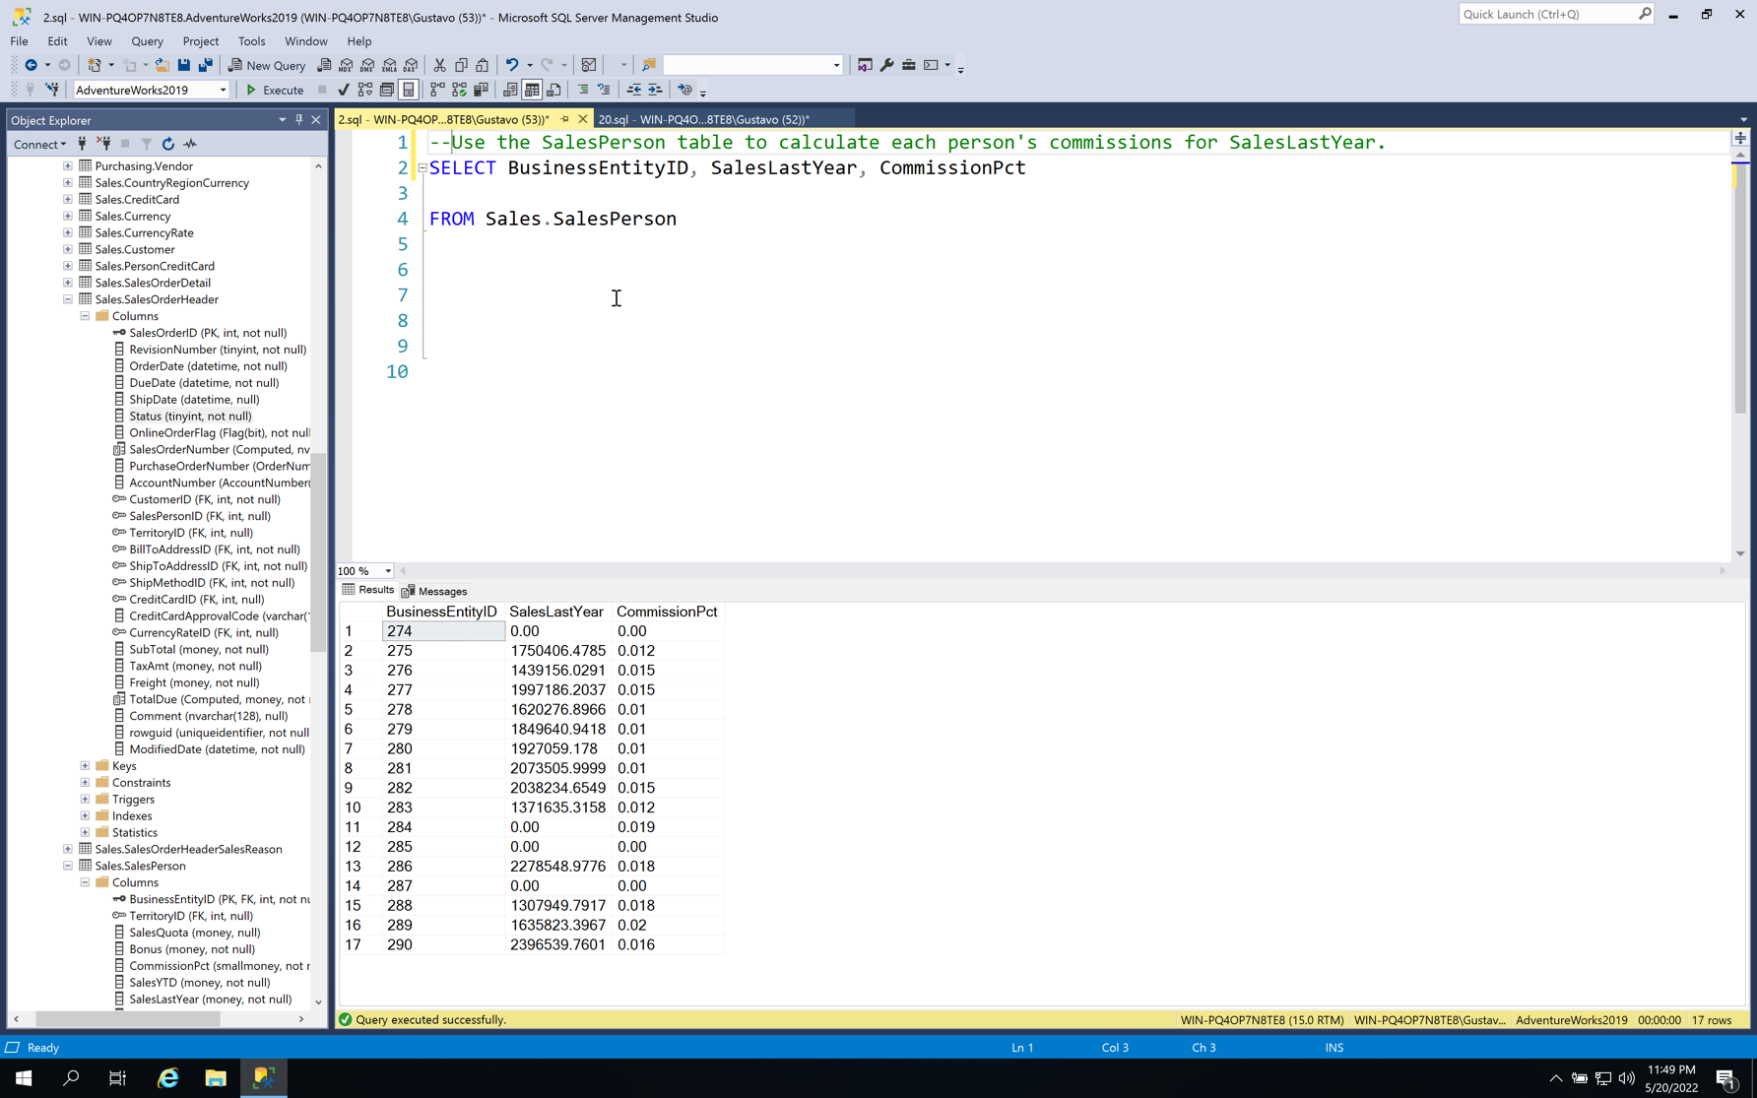

1. In the sales order header table, find all lines where the sale is between March 2013 and February 2014

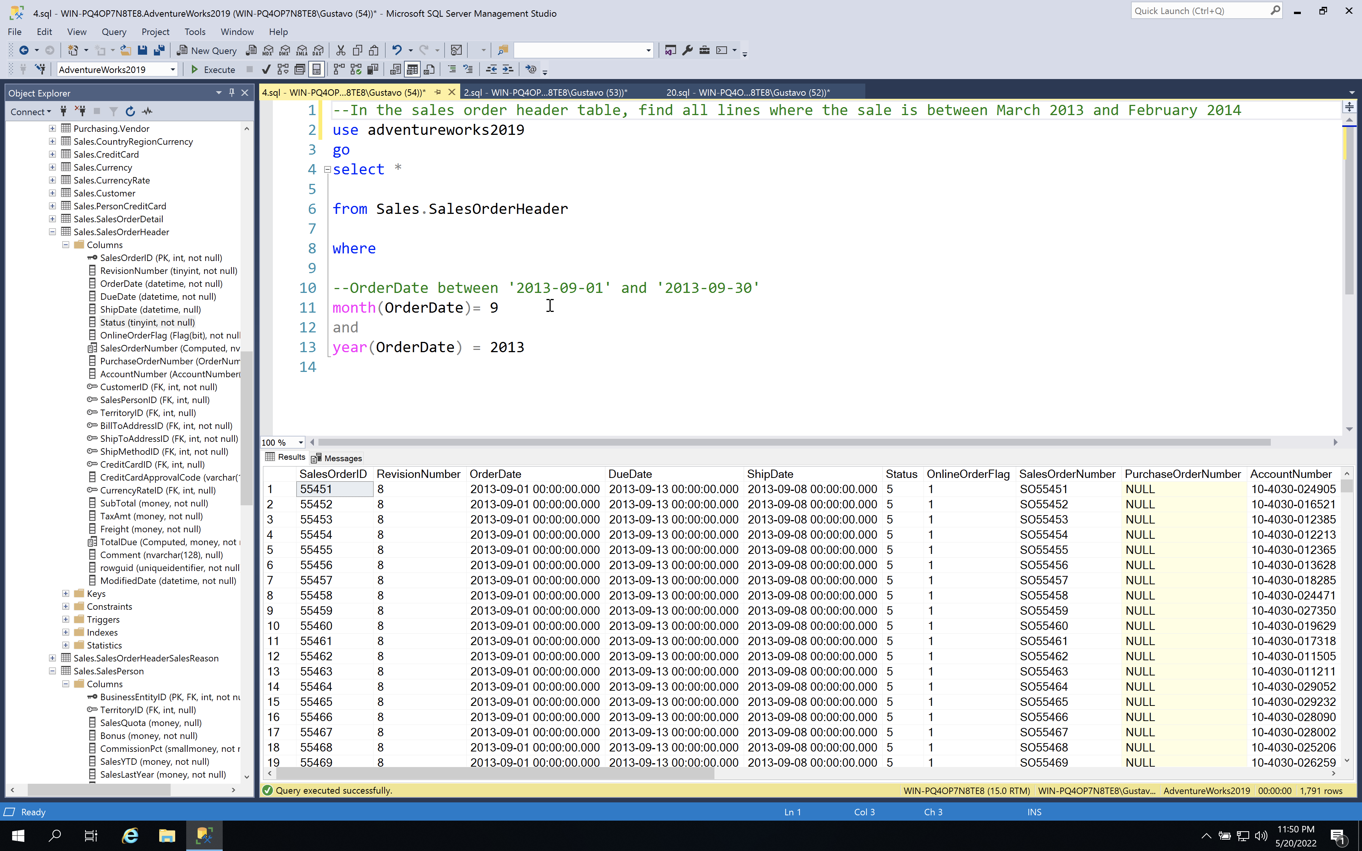

1. All products that have “decal” or “bolt” in the name

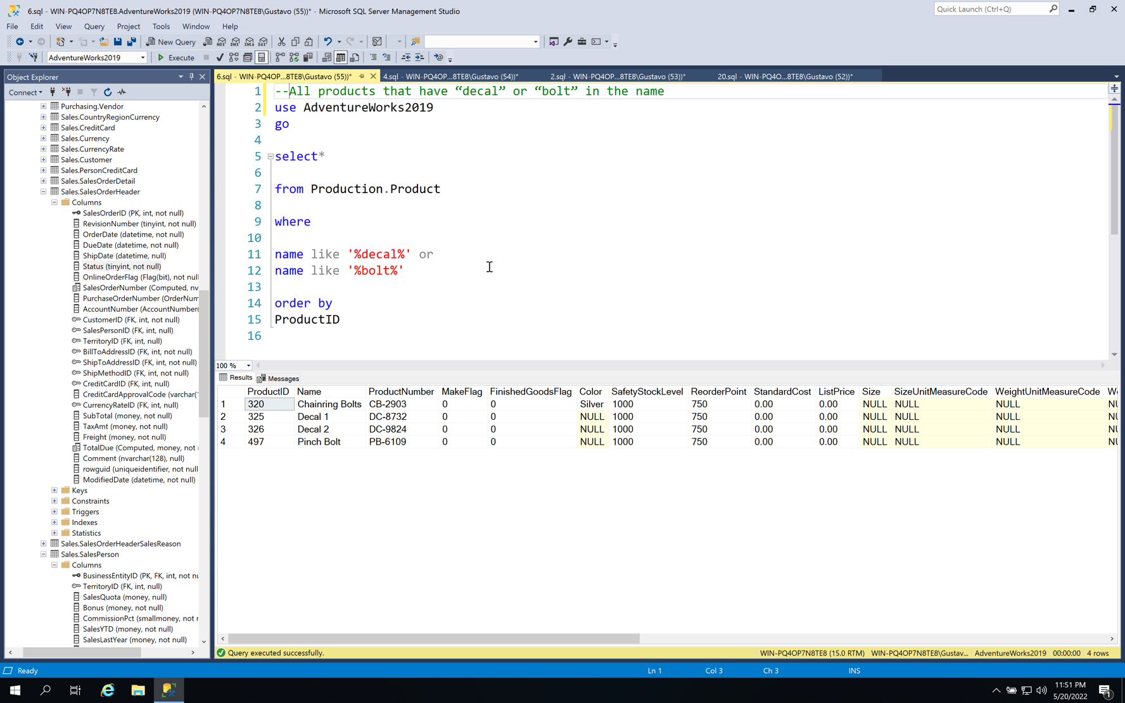

1. From the departments table, create the complete department and group name by combining the name and the group name. ie ‘Engineering – Research and Development’

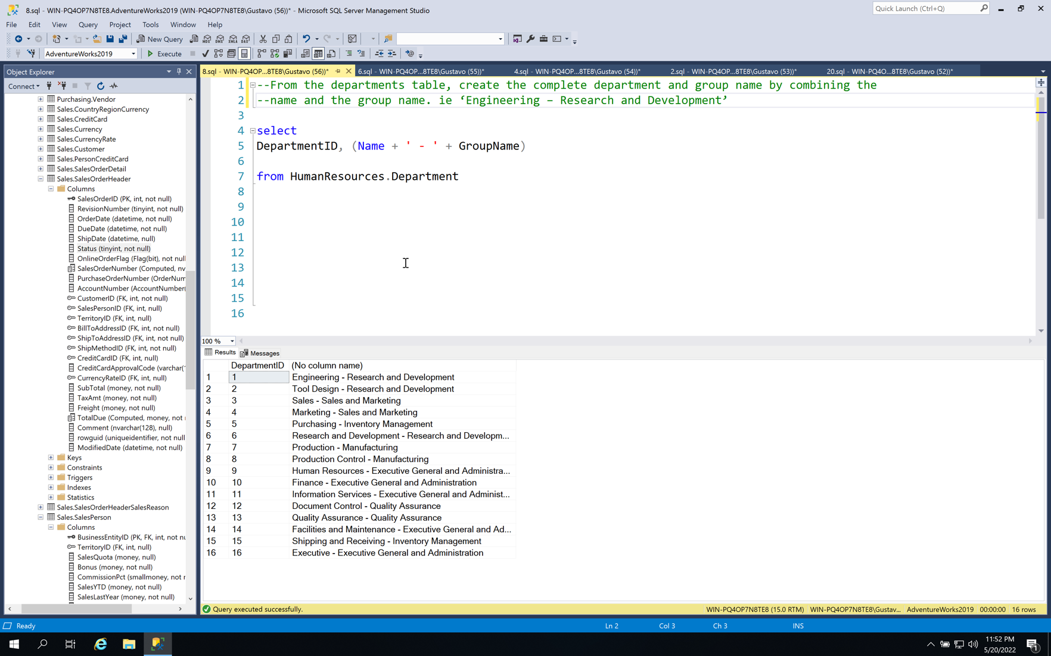

1. Find all the products with a standard cost of more than $1000, and in the product name column have the column name be "ProductName"

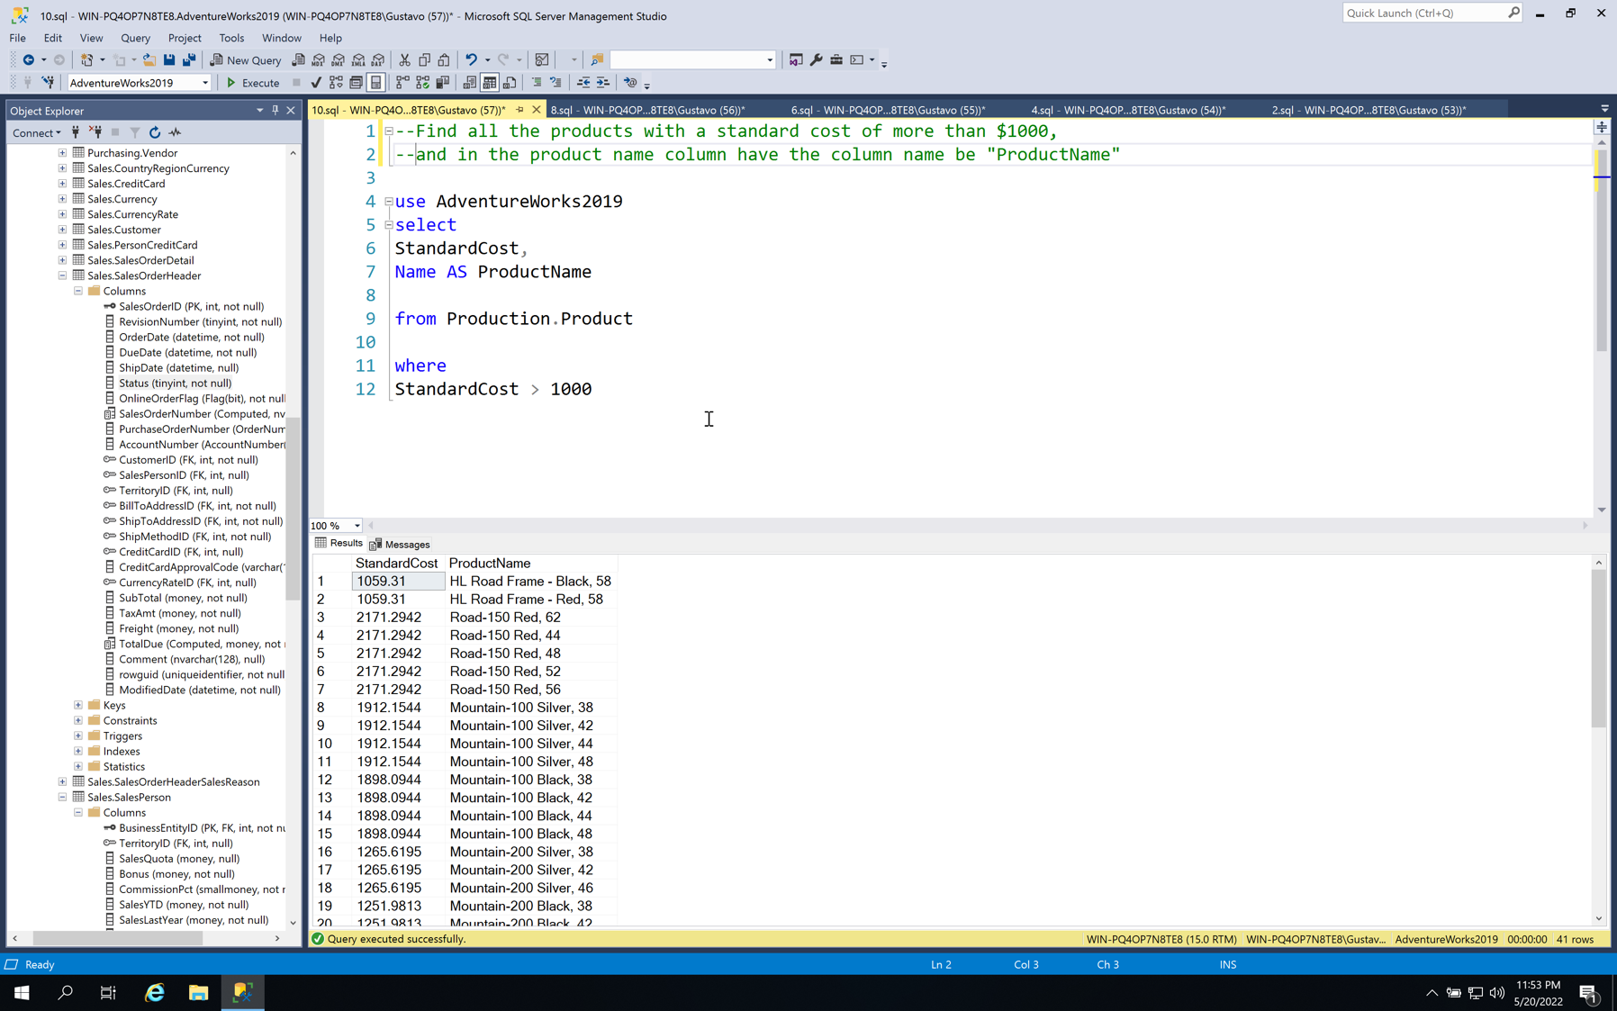

1. In the product table, find the standard cost plus the list price

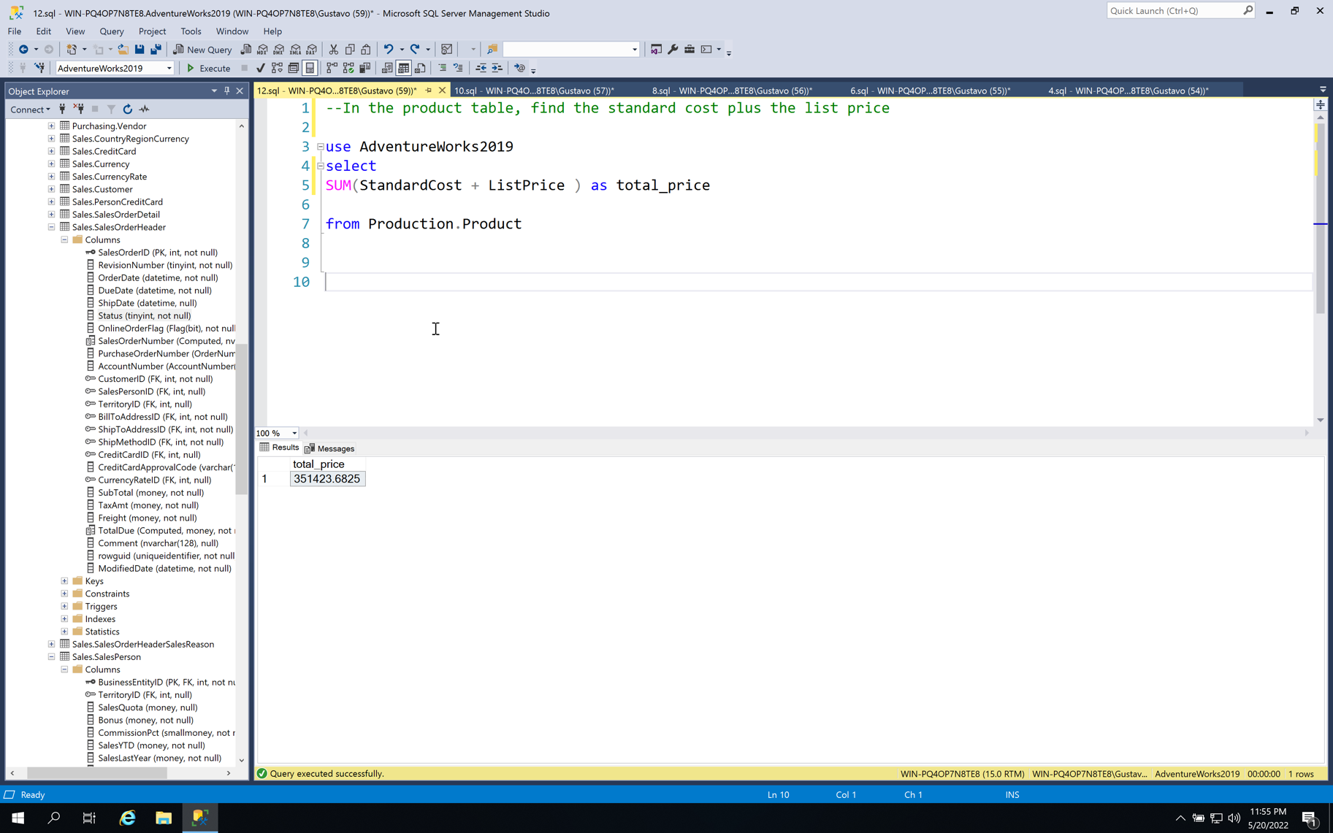

1. In the product table, The safety stock level times the list price where the product color is silver

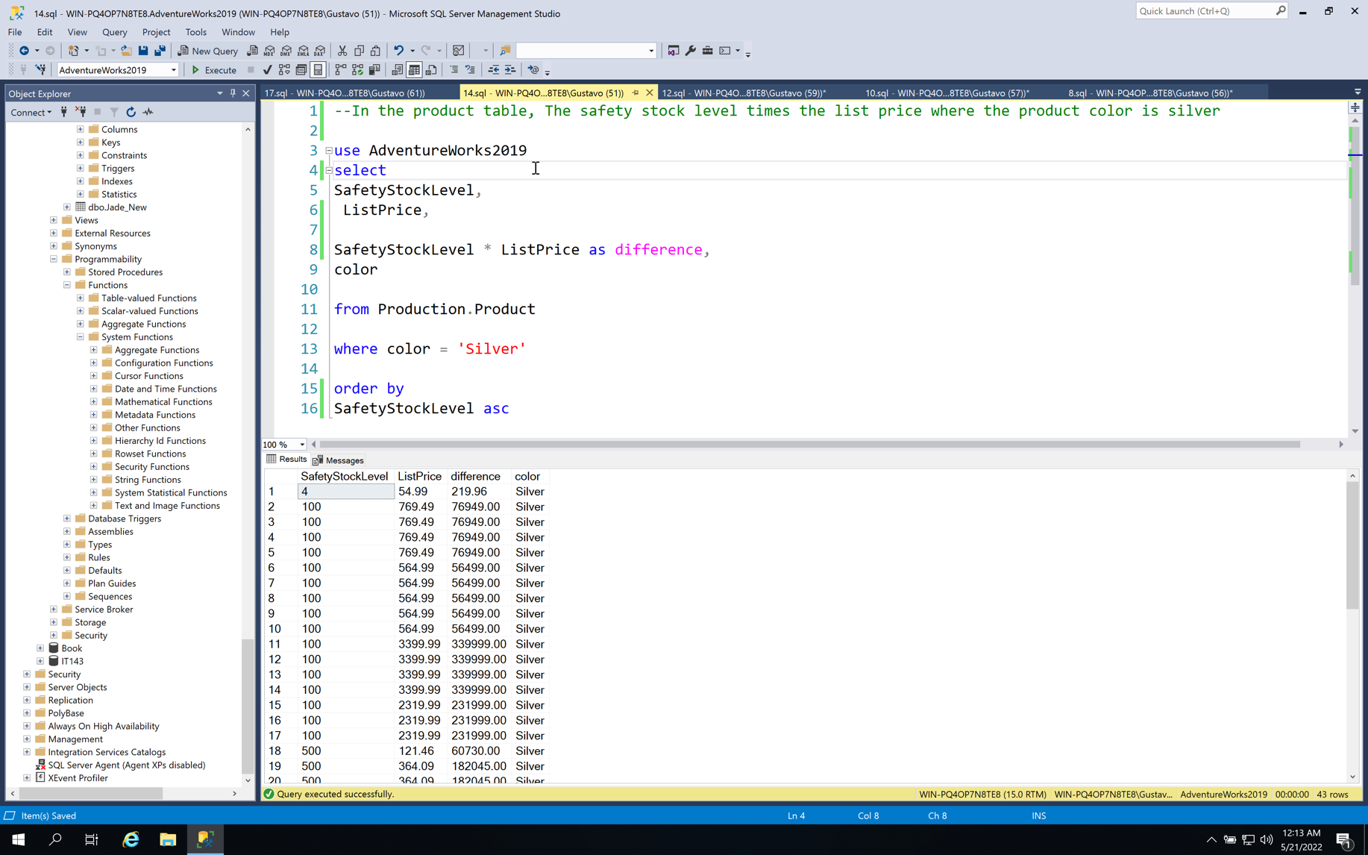

1. Find the products that are colored red, white, or blue and cost less than $100

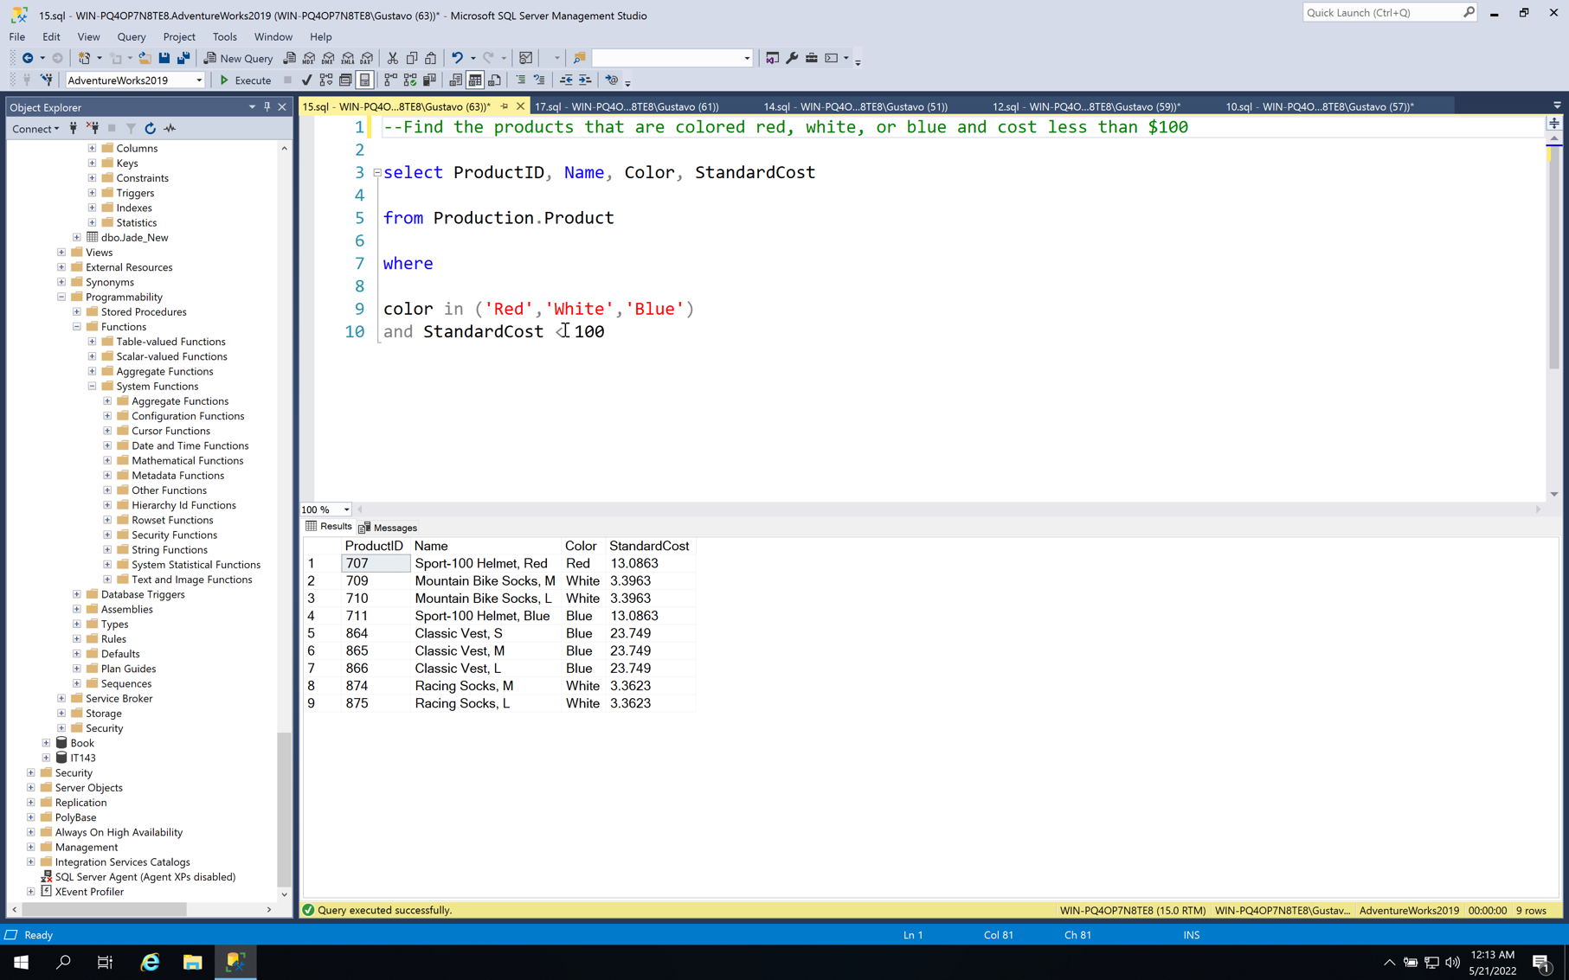

1. Find the products have a safety stock level of less than 600

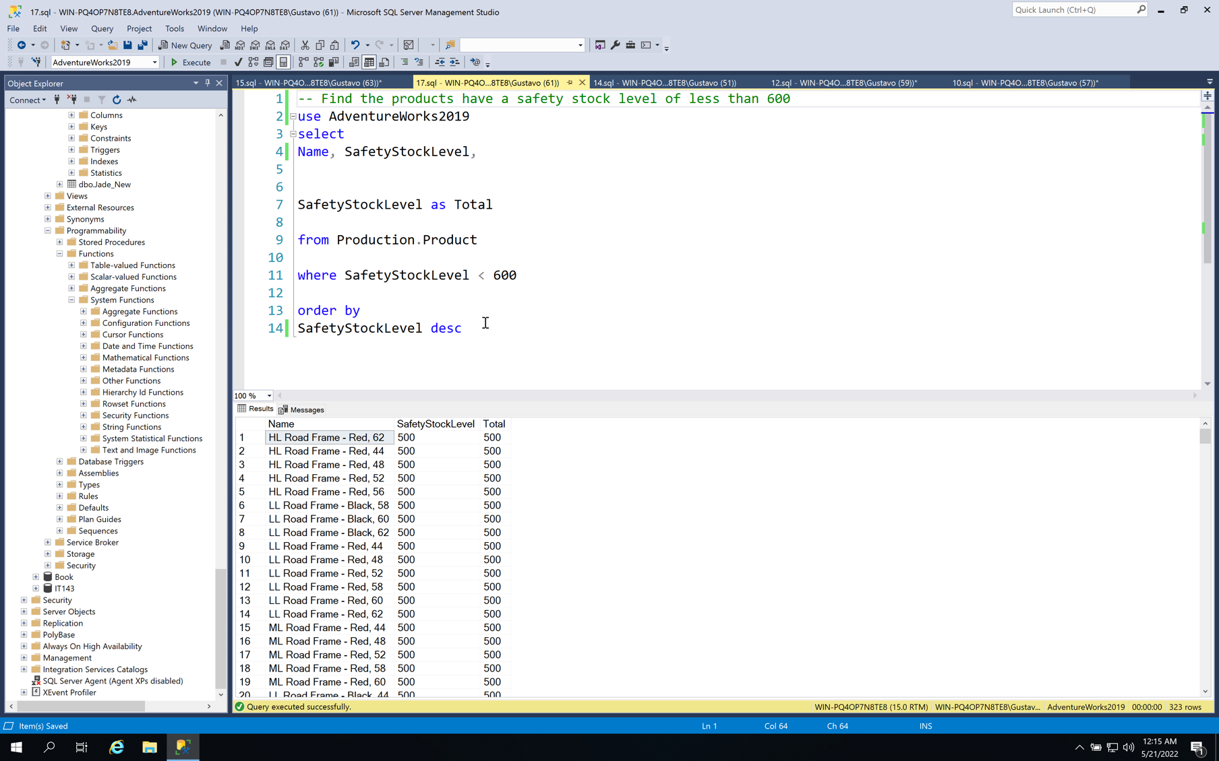

1. Find all the sales order headers with a subtotal less than 3 or greater than 100,000 that were purchased in June of 2013

